**Ideation Phase**

**Brainstorm & Idea Prioritization Template**

|  |  |
| --- | --- |
| Date | 13 March 2025 |
| Team ID | PNT2025TMID06726 |
| Project Name | **Predicting Plant Growth Stages with**  **Environmental and Management Data** |
| Maximum Marks | 4 Marks |

**Brainstorm & Idea Prioritization Template:**

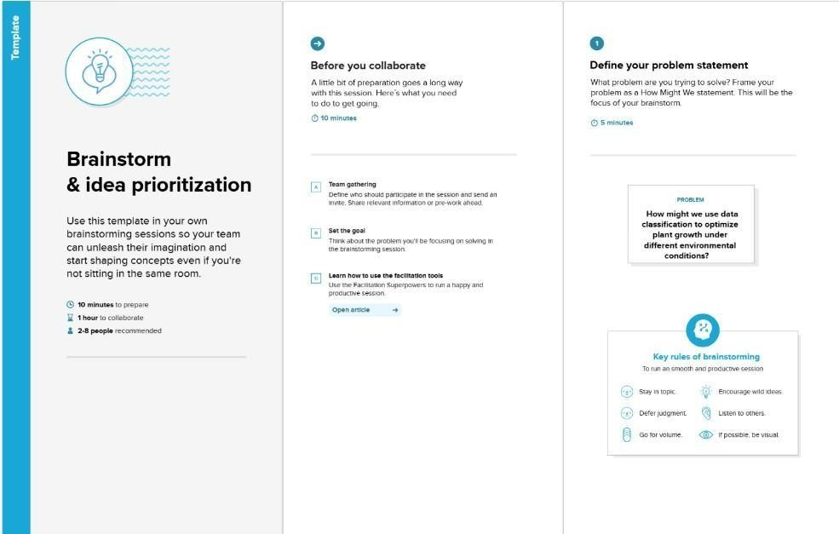

**Step-1: Team Gathering, Collaboration and Select the Problem Statement**

**Problem Statement:**

Farmers and agritech companies struggle to **predict plant growth stages** accurately due to varying environmental conditions like **soil type, sunlight exposure, water frequency, temperature, and humidity**.

**Project Goal:**

Using **Power BI**, we aim to analyze plant growth patterns and provide **data-driven insights** to optimize farming strategies and improve **crop yield and sustainability**.

**Step-2: Brainstorm, Idea Listing and Grouping**

**Brainstormed Ideas for the Project**

1. **Data Collection & Preparation:**
   * Collect environmental and management data (soil type, water frequency, etc.).
   * Ensure data quality by handling missing values and inconsistencies.
   * Import and transform data in **Power BI**.
2. **Data Analysis & Key Metrics:**
   * Identify **growth trends based on different environmental conditions**.
   * Use **DAX measures** to calculate insights like average growth, highest/lowest temperature impact, etc.
   * Apply **data filters and slicers** to explore different growth conditions.
3. **Visualization & Dashboard Creation:**
   * **Stacked Bar Chart:** Soil Type vs. Growth Milestone (stacked by Fertilizer Type).
   * **Scatter Plot:** Sunlight Hours vs. Growth Milestone (colored by Soil Type).
   * **Line Chart:** Temperature vs. Growth Milestone (to track environmental impact).
   * **Pie Chart:** Distribution of Water Frequency or Fertilizer Type.
   * **Card Visuals:** Total Plants, Average Growth Milestone, Most Common Soil Type.
4. **Predictive Insights & Business Impact:**
   * Use a **Decomposition Tree** to break down **factors influencing growth milestones**.
   * Provide insights on **optimal soil type, watering schedule, and environmental conditions**.
   * Support **precision agriculture and smart farm management** using data analytics.

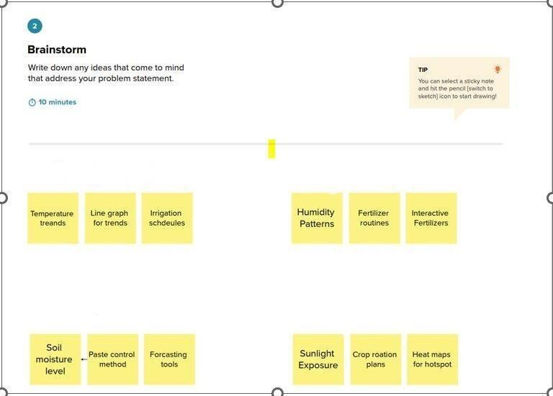

**Step-3: Idea Prioritization**

|  |  |  |
| --- | --- | --- |
| **Idea** | **Priority Level**  **(High/Medium/Low)** | **Reason for Priority** |
| **Data Cleaning & Transformation** | High | Essential for accurate insights |
| **Stacked Bar Chart (Soil Type vs**  **Growth)** | High | Shows key environmental impact |
| **Scatter Plot (Sunlight vs**  **Growth)** | High | Helps find correlation |
| **Decomposition Tree (Growth**  **Analysis)** | High | Breaks down key influencing factors |
| **Card Visuals (Key Metrics)** | High | Provides quick insights |
| **Predictive Insights** | Medium | Future enhancement |
| **Advanced AI-based Predictions** | Low | Needs further data exploration |

